# CSSE3101 – ADVANCED WEB TECHNOLOGIES

# MERN STACK DEVELOPMENT

# Objective:

In this lab activity, you are going to Read data from the MongoDb database and display on the React application. You will read all the documents and specific documents based on some criteria.

**PART 1- Express Route–Server-side script retrieve all students documents**

Create the Express GET route for retrieving all the records from the database.

* .find() method – retrieves all the records
* .countDocuments() method – counts the number of records

//express GET route for retrieving all the records from the database

app.get("/getAllStudents", async (req, res) => {

        const students = await StudentModel.find()

        const count = await StudentModel.countDocuments({});

        res.send({ students, count});

});

**PART 2- APPLICATION SETUP**

1. In the client folder, update ShowStudents.js component by doing the following:
2. Import the following:

import React, { useState, useEffect } from "react";

import Axios from "axios";

1. Create state variables using useState hook.

const [listOfStudents, setlistOfStudents] = useState([]);

  const [countRecords, setcountRecords] = useState(0);

1. Create a useEffect hook to accept the response from the server.

useEffect(() => {

         Axios.get("http://localhost:3001/getAllStudents")

            .then((response) => {

                    setlistOfStudents(response.data.students);

                    setcountRecords(response.data.count);

                })

            .catch((err) => {

                    console.log(err);

            });

     }, []);

1. In the <tbody> use the map() function to iterate over the response and display the data.

 listOfStudents.map((s) => {

                          return (

                              <tr>

                                  <td>{s.studId}</td>

                                  <td>{s.studName}</td>

                                  <td>{s.gender}</td>

                                  <td>{s.email}</td>

                                  <td>{s.dept}</td>

                              </tr>

                          )

                      }

                      )

1. Display the number of records.

 <div>

  <h3>Number of Records: {countRecords}</h3>

 </div>

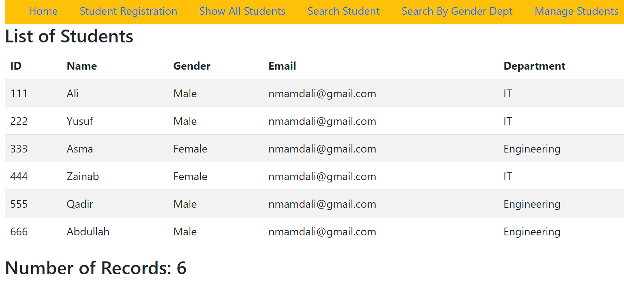

1. Update the **App.js** and add the following **link** and **routes**:
   * + /home – render the Home.js component
     + /stdreg – render the StudentRegister.js component
     + /stdshow – render the ShowStudents.js component

**PART 3- Express Route– Writing Server-side script to retrieve a specific document**

Update the index.js Write **“/getStudent”** Express route to retrieve a specific student document based on the student id from the MongoDb collection. Use the mongoose method to retrieve the documents based on the product brand chosen by the user.

//express GET route for a specific student document

app.get("/getStudent/:id", async (req, res) => {

    try {

        const id = req.params.id;

        const student = await StudentModel.find({studId: id});

        res.send({student});

        } catch (err) {

        console.error(err);

        }

});

**PART 4- APPLICATION SETUP**

In the folder client/components, create a new component named GetStudentById.js. The component

Includes:

1. Input screen to get student id.
2. Create the state variables using the appropriate Reach Hook for the following:

const [studId,setStudId] = useState("")

 const [student, setStudent] = useState([]);

1. Add the corresponding event handlers to set the value of the respective state variable dynamically based on user input.
2. Write the code to make the function call to the getStudent() function when the user clicks the **“Search Student”** button. Send an **Axios get request** to the server to retrieve a student document of

Student whose id is entered on input control. Service end point is “**/getStudent**”.

const getStudent = async () => {

     Axios.get(`http://localhost:3001/getStudent/${studId}`)

         .then((response) => {

             console.log(response.data.student);

             setStudent(response.data.student);

            }

            );

    };

1. Update the **App.js** and add the **link** and **route**:

/stdsearch – render the GetStudentById.js component

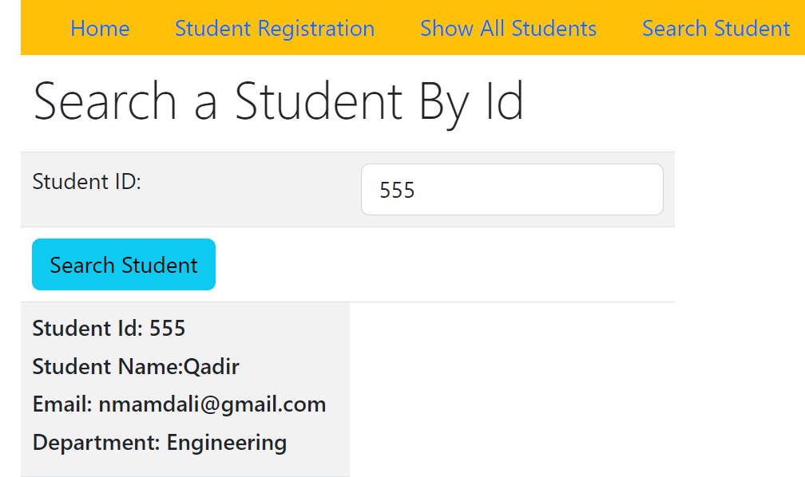

Required Submission.

Once you complete the lab activity, you are required to upload the database model file student.js, server folder and src folder of the client app.